Truckers Night at the Museum
To benefit the Truckers PAC of Virginia
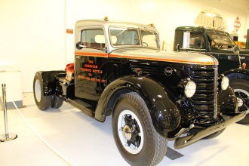
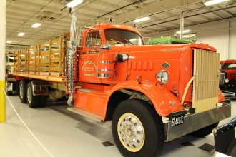

REGISTRATION FORM

(Registration fee includes admission to the museum, dinner catered by Sibley’s Bar-B-Que and non-alcoholic beverages.)

For PAC contributions, make payment to Truckers PAC of Virginia!

 | Attendees | @ | $50 per person | = | $ | (Total Fees Due)

Name(s) ______________________________________________ Badge Name______________________________
________________________________________________ Badge Name______________________________
________________________________________________ Badge Name______________________________
________________________________________________ Badge Name______________________________
Company__________________________________________________________________________________________
Address____________________________________________________________________________________________
Phone___________________________________________________ Fax_______________________________________
Email Address_____________________________________________________________________________________
________ Check here if any registrant has special dietary needs and we will contact you for appropriate arrangements.
_____ Check Enclosed–Checks for PAC contribution MUST be payable to Truckers PAC of Virginia!
Checks for VTA should be made payable to Virginia Trucking Association
_____ Pay by Credit Card for: Truckers PAC of Virginia
Virginia Trucking Association
Card #: |  |  | Expiration Date:
Name on Card: |  |  | Security Code:

Return by mail to: | Virginia Trucking Association  4821 Bethlehem Road, Suite 101  Richmond, VA 23230 | or  or | Fax to: 804-355-5371  Scan and email to: rbolton@vatrucking.org

PLEASE RETURN REGISTRATION AND PAYMENT NO LATER THAN APRIL 26, 2017

