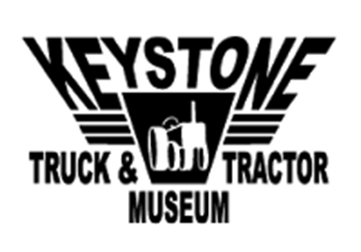

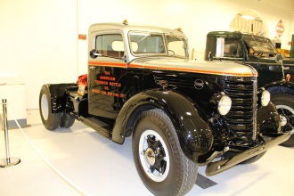
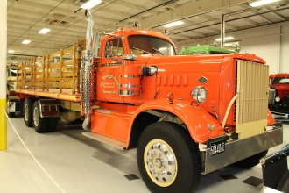
Truckers Night at the Museum
To benefit the Truckers PAC of Virginia

SILENT AUCTION DONATION FORM

The First Truckers Night at the Museum will feature a silent auction to provide some friendly, competitive entertainment and raise additional funds for the Truckers PAC of Virginia. The success of the auction will depend on donations and contributions of items and prizes for attendees to bid on. Any items of value or interest that will generate interest and entice people to bid will be welcomed. Suggested ideas include stays at vacation homes, tickets to sporting events, goods and services, gift cards or any other unique donations you can think. For example, model trucks or other memorabilia from your company would certainly be appropriate for an auction at a museum! In lieu of a tangible item, you can contribute money that we will use to buy things to put up for auction.

Complete the form below to make your donation and return it to the VTA no later than April 26, 2017!

Company: ______________________________________________ Contact _____________________________________
Address: ________________________________________________ Email: _____________________________________
City: _________________________________________ State _____________________ Zip: _____________
Description of Item(s) | Estimated Value
1. | $
2. | $
3. | $

I would like to donate $ to purchase items to be put up for auction.
_____ Check Enclosed – Checks MUST be made payable to the Truckers PAC of Virginia!
_____ Pay by Credit Card to Truckers PAC of Virginia -- please provide the following information.
Card #: |  |  | Expiration Date:
Name on Card: |  |  | Security Code:

Return by mail to: | Virginia Trucking Association  4821 Bethlehem Road, Suite 101  Richmond, VA 23230 | or  or | Fax to: 804-355-5371  Scan and email to: rbolton@vatrucking.org

PLEASE RETURN DONATION FORM OR CASH CONTRIBUTION NO LATER THAN APRIL 26!

